SKI HAWKS OTTAWA (SHO) FALL 2017 NEWSLETTER

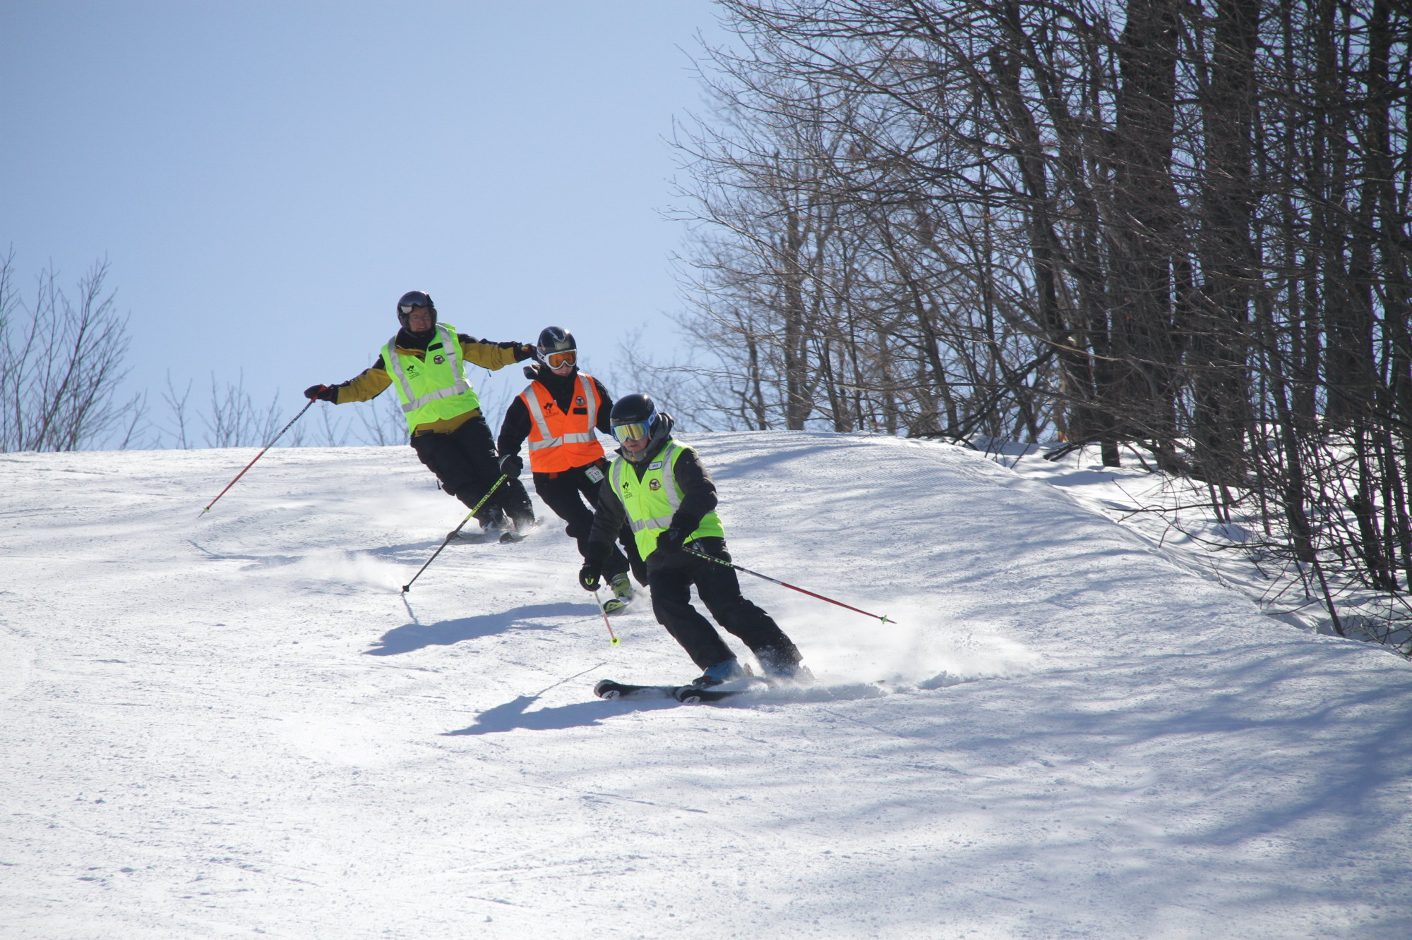

Table of Contents
President’s Message……. 2
Online Registration…….. 2
In-Person Registration at the Fox and Feather 2
Guide Training Day………. 3
Calendar of Events……… 3
Guide Recruitment……… 3
CADS Certification………. 4
CADS Manual.....… 4
Operations Manual……. 4
Drivers for Wednesday night…… 4
Skier Weekly participation……. 5
CADS Annual Festival….. 5
March Saturday Day Trip to Mt. Avila… 5
Ottawa Community Foundation… 5
SHO Web site…….. 6
Stay Connect with us on Facebook….. 6
CADS – NCD AGM November 1… 6
Safety and Awareness Questions…….... 7
Helmets and Safety Device…….. 7
Camp Fortune and other Partnerships 7
The Great Pumpkin Annual Ball…….. 7
2017-2018 Grade 4 & 5 SnowPasses now available …… 8

President’s Message

During the Fall, our Board of Directors is always very busy preparing for the beginning of the program. We are organizing the registration activities; recruiting new guides and skiers; planning the training day; and sending out several messages from the Canadian Adaptive Snowsports Association (CADS), CADS-National Capital Division (CADS-NCD) and our own program (SHO).

This year, there will be a whole new registration system that has been set up by the CADS National office. You will no longer have to register on two sites. The one registration form will work for both. We are currently in the process of adapting the CADS form for Ski Hawks purposes and there will be an email sent out as soon as it is ready. We are aiming for a November 1 roll-out.

As in past years, CADS-NCD has set up a full rooster of certification days for volunteers to become CADS-certified, so I am encouraging all interested guides to take a look below and see if any of the training/certification interests you. We are going to suggest that all guides look at taking the VI Specialty course when you feel ready. For this year, we have arranged for a CADS examiner to deliver the course at Camp Fortune on Sunday, February 18, from 9 a.m. – 2 p.m. You will have to have the CADS CSIA methodology course under your belt or already be CSIA certified to take the course. We will be offering the CSIA methodology course over 3 evenings at the beginning of January at Camp Fortune.

I look forward to seeing everyone soon and, as always; please do not hesitate to contact me if you have questions or suggestions to improve our program.

Carolyn Mitrow (check out the new CADS logo)

Online Registration

As mentioned above, there is a new process to register. A separate email with the details will be sent out to all members within the next two weeks. The annual CADS fee for all is $35 this year and for all skiers, due to the CADS increase of $5, the fees for skiing will rise by $5. Skiers/boarders with equipment will be required to pay $105 and skier/boarders who plan to rent, will be required to pay $130.

In-person Registration Night at the Fox and Feather Restaurant –November 15

For existing or new members who would prefer to register in person, we will have a registration evening at the Fox and Feather Restaurant, 283 Elgin Street, on Wednesday, November 15th, from 5:30 p.m. – 8 p.m. We will have computers available on site to assist you with your registration. This event is a great way for new members to meet some of the Board members and for others to gather and get caught up on summer activities. Everyone is welcome, even if you have already registered.

Guides: Please, please, please register by December 1st in order for us to determine whether or not we need to recruit more volunteers.

Guide Training Day – December 3 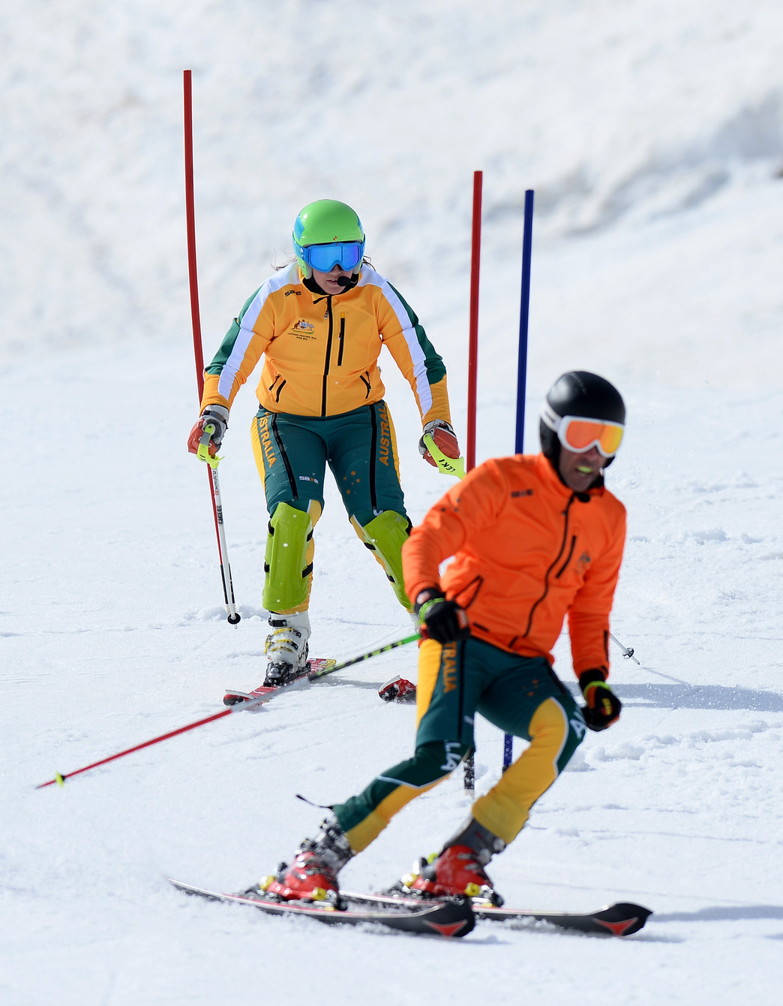

The guide training is mandatory for all volunteers planning on participating as guides. For the new guides, it is an opportunity to learn how to guide from other experienced guides, and for all others, it is a chance to get out on snow and dust off your guiding brain and re-program yourselves on how to best lead our skiers down the hill. This training will include hill safety, program protocols, new safety questions, guiding techniques for new guides, and training on teaching methods specific to instructing skiers on how to learn to ski. Guides who are unable to attend this training day must contact Robin Morrin, our new Technical Director at (343)998-6200.

CALENDAR OF EVENTS, including guide training days (also available on our Web site)

SHO Calendar of Events 2017-2018.docx

GUIDE RECRUITMENT

CALL OUT TO EVERYONE! We are always recruiting for more guides – especially guides who have the ability to drive our skiers to the hill. If you know of anyone who is interested, please have them contact Robin Morrin at (343) 998-6200 or rdmorrin@hotmail.com.

CADS CERTIFICATION

As mentioned above, the CADS-NCD Technical Committee has set all of the training and certification dates for 2017-2018. The focus remains to give all of the modules for volunteers to be able to complete either their CADS I or CADS II levels.

For SHO guides, the certification process offers flexibility, which wasn’t offered under the old certification process. Guides can continue do the full certification at each level (I through IV) as in the past, or, under the new modular system for certification, there is a module for visually impaired (VI) specialization. This means that SHO guides can take a CADS Level I VI module and then later take a CADS Level II VI module without having to complete all the other CADS modules at Level I or II. If successful at each level, you will be recognized as a VI Specialist.

At the Guide Training Session scheduled for December 3, the CADS certification process and the 2017-18 schedule of training will be explained. This certification process is not mandatory, but you are encouraged to upgrade your skills. It will be free again this year as SHO will cover the course fees.

SHO will aim to set up a training night before the VI module to prepare the course participants; Jeff Boucher will be doing training for volunteers interested in taking modules, every Tuesday night at Edelweiss. He needs to know in advance what folks are interested in, so please let him or Robin know on Wednesday nights.

To register for CADS training, please visit http://disabledskiing.ca/.

CADS Manual

The SHO Board is very supportive of the CADS Technical Committee’s direction and has bought PDF and hard copy versions of the CADS Manual. All new guides will receive a manual or a link to the manual upon registration.

Operations Manual

The Club operations manual is posted on our Web site and updated yearly. Comments, questions etc. are encouraged. Let your Board members know if it answers all of your questions about our club.
Drivers needed for Wednesday Night

We are calling out to volunteer drivers who can provide transportation to skiers. If you are available to pick-up and/or drop-off a skier on Wednesday night, please let Murielle Arseneau know via email at marseneau@bell.net. Murielle has coordinated rides for more years than I can count now and she is superb at it, but it isn’t always easy. Her constant concern is that she won’t have enough drivers to get all the skiers up to the hill and home again. Kim Leahy also assists when Murielle isn’t available and she will also need your support when planning weekend events.

Please note that if you can only drive a skier one way, that is still a big help to us as we can try and arrange for a driver for the other way. You can let us know about your driving availability on the Ski Hawks registration site or simply inform Murielle.

Skier Weekly Participation

Skiers will be able to confirm their attendance by completing the Weekly Skier Notification Form on our Web site and submitting it before 9 p.m. on Sunday. Murielle will collect the notifications at that time and start planning for the following Wednesday.

CADS Annual Festival

The 2018 CADS Festival will be held at Mont Ste. Anne, Quebec, from March 19 to 23, 2018. Attending the festival is an experience of a lifetime for anyone who has never been. You will not be disappointed!

If you are interested in participating, please advise Robin Morrin or James Dicks as soon as possible so that planning, fundraising and any necessary ski skill development can be facilitated throughout the entire season. Visually impaired skiers must find their own guide who is willing to go and pay their own way. It is best if skiers and guides go in teams of two or three - 1 skier along with 1 or 2 guides.

For people wishing to attend, they should consider the costs for transportation, accommodation, meals, equipment rentals, if needed, personal incidentals, etc. As was the case in past seasons,

CADS - NCD is looking to provide some funding for the festival. Ski Hawks is also budgeting some funds to help partially subsidize anyone going. Registration for the CADS Festival will be open on the CADS Web site starting in November.

March Saturday Day Trip to Mt. Avila

As in previous years, all SHO members are invited to attend the March fun day at Mt. Avila on Saturday, March 3, 2018. Skiers/boarders must find their own guides to attend. The CADS-NCD event is very inexpensive and members are bussed to the ski hill for a day on the slopes. Kim Leahy will be coordinating the event for SHO members again and will send out an email in early February with further logistical details. If you have any questions regarding this outing, please contact Kim at kmcleahy@gmail.com or at (613) 286-0440.

The Board of SHO applied for a grant from the Ottawa Community Foundation and were very fortunate in receiving funds to purchase 20 radio sets for the guides and skier/boarders. We will also have some funds available to support CADS training and safety devices used on Wednesday night. Some of our skiers had the benefit of trying Bob Isaksson’s set last year and loved them. Everyone will now be able to benefit from hearing the guide’s voices above all of the noise on the hill.

Please visit our Ski Hawks Ottawa Web site
You can find useful information about our program on our Web site: http://www.skihawksottawa.ca , such as key contacts, calendar of events, operations manual, etc.
We make an ongoing effort to keep the Web site up-to-date, thanks to the help of Steve Giorno, our Webmaster and former SHO volunteer. We are also making every effort to provide key documentation in French and apologize for any material that hasn’t been translated.

Stay Connected and Join us on Facebook
Did you know that Ski Hawks Ottawa has a Facebook page (Facebook.com/skihawksOttawa)? Follow us to stay informed of special announcements, reminders or cancellations, etc.

CADS - NCD Annual General Meeting - November 1, 2017

This is a reminder that you are invited to the CADS - NCD Annual General Meeting on Wednesday, November 1, 2017, at St. Anthony’s Italia Soccer Club, 523 St. Anthony Street, (Off Preston Street at the Queensway) at 5:15 p.m. for light refreshments and a start around 6 p.m.

Ski Hawks Ottawa is a member of CADS - NCD and, as such, our CADS registered members are eligible to participate in the votes and have a say in the matters of the Division. It is very important that we have representation from our members. Hope some of you can make it.

You are eligible to vote if you were a CADS member last year or if you have registered with CADS for this year.

During this AGM, an election will be held for two (maybe three) Directors to sit on the CADS - NCD Board. Dedicated members with experience in Administration, Finance, Translation, Information Technology and or Fundraising are encouraged to apply.

If you wish an application form, please contact our Nominations Committee Chair, David Farough at DFarough@gmail.com. Complete the application form and email it David and CC Bruce Meredith, Nominations Committee member, at brucemeredith@rogers.com.

The deadline to submit applications is midnight Ottawa time on October 27, 2017. There will be no calls for nominations from the floor. Please note that two (2) current CADS-NCD members in good standing are required to support each nomination.

Safety and Awareness Questionnaire for Guides

With a constant focus on improving the safety of our program, the Board will continue to use the completion of the safety questions as a pre-requisite to guiding each year. Questions will be discussed at the training session on December 3. All guides must review the safety questions with a trainer prior to guiding.

Helmets and Safety Devices

As an important reminder, helmets are MANDATORY for skiers and it is HIGHLY encouraged that guides also wear helmets for their own safety. Also, skiers and guides must wear their vests and flashing lights to make themselves more visible on the slopes.

Camp Fortune and other Partnerships

For close to 40 years, Camp Fortune has been our key partner and ongoing supporter of our program. Camp Fortune is once again subsidizing our program, which allows us to participate with minimal equipment charges and lift ticket fees.

Kunstadt Sports has also been a strong supporter of our program and I encourage everyone to support them. They will provide discounts to you if you show them your CADS membership card.

The Great Pumpkin 11th Annual Ball
Folks, are you looking for something fun to do for Halloween? Look no further. The 11th Annual Great Pumpkin Charity Ball in support of the Canadian Cancer Society, the Canadian Association for Disabled Skiing - National Capital Region, St. Jude Children's Hospital and the 2017-2018 Grade 4 & 5 SnowPasses now available

http://greatpumpkinball.com/

Snow Pass for Grade 4 & 5 students

The SnowPass helps to keep kids active during the winter months and is one of Canada's easiest ways to get kids healthy and active. It's an unbeatable offer; it provides 5 free lift passes at each of the 150+ ski areas nation-wide for Canadian kids in Grade 4 and Grade 5.
You only need to apply once for the SnowPass and the pass is valid until the end of Grade 5. This means if you apply in grade 4, the pass is valid for two years. To sign up, visit https://www.skicanada.org/grade-4-5-snowpass/Ottawa Food Bank is being held Saturday, October 28.

