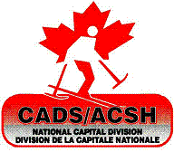
CADS-NCD - Mont CASCADES
Budget 2016/2017

Revenues
2015/16 carry over $1,000
10 Skiers @ $ 200 registration $2,000
Fundraising $1,000
Corporate Donation $ 500
Total $4,500

Expenses
Lift Tickets 22 Skiers x 8 weeks x $15 $ 2,640
Plaques / achievement awards $ 360
Bursary for Festival participation (athlete) $ 1,000
Achievement celebration $ 500
Total $ 4,500

Rev. 29 October 2016

