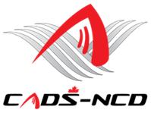
“SKIING IS FOR EVERYONE”
Mont CASCADES
Budget 2018 – 2019
Revenues
Initial carryover $ 1,793
12 Skiers @ $ 250 registration $ 3,000
Donations $ 1,000

Total $ 5,793
Expenses
29 Skiers x 8 weeks x $15 $ 3,480
TC Contribution $ 380
Plaques / achievement gifts $ 500
Bursary for Festival participation $ 500
Equipment maintenance $ 233
Achievement celebration $ 700
Total $ 5,793
Rev. 22 October 2018

