**President’s Report**

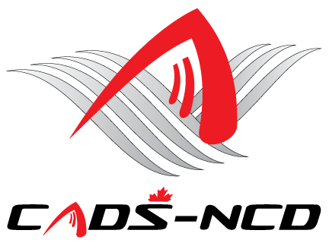

**Annual General Meeting**

**November 17, 2021**

# 

# CADS – NCD President’s Report

I am so pleased to submit my President’s Report for the CADS – NCD 2020-2021 fiscal year from July 1, 2020 to June 30, 2021.

Due to the onset of the pandemic into the national capital region during spring 2020, CADS – NCD was unable to be on the snow during the winter season from late 2020 into early 2021. CADS – NCD showed its resilience and resolve but remained safe through the 2020-21 ski and snowboard season. We look forward to returning to the hill in a safe manner complying with guidance set out by public health, governments, sport, resorts hosting our programs, and CADS.

During summer and fall 2020, the CADS – NCD COVID 19 Safety Officers Working Group worked very diligently to develop a Return to Snow Plan for the Division and each of our Programs. The Working Group is currently updating these plans as a means to guide our return to the snow anticipated for 2022.

I continue to appreciate and acknowledge all the support provided by the resorts hosting our programs; Camp Fortune, Mont Cascades, Somet Edelweiss, Mount Pakenham and Calabogie Peaks.

CADS – NCD continued to receive donations from our supporters. I sincerely thank all new and recurring sponsors who donated financially to CADS - NCD and our programs. Put simply, we could not do what we do without your generosity. Fundraising provided a solid financial backbone for our programs and services. Your efforts and generosity will continue to help us operate all our programs, train instructors, support travel to events, and purchase expensive adaptive equipment necessary to make it all happen.

CADS – NCD is a not for profit charity so the business to manage it continues during the pandemic. Thank you to our external partners, volunteers, program leadership groups, and the CADS - NCD Board of Directors for your continuing support, dedication, passion and for the time you give to enrich lives of our participants. I appreciate the strategic advice provided by the CADS – NCD Board of Directors and CADS National. You all enabled CADS – NCD to conduct our affairs on and off the hills in effective and efficient manner. This makes CADS – NCD a most successful and dynamic Division within CADS. We are the best.

Our public accountant BDO Canada once again confirmed that CADS - NCD financial affairs are in good standing order. Due to the unpredictability of the pandemic CADS – NCD has managed its resources very carefully.

As we look towards next year CADS – NCD’s 43rd year of operation, the division and all our programs are updating their management plans for operation in the COVID-19 era. The plans will take into account the guidance from public health, government, sport, host resorts, and CADS. CADS – NCD is an adaptive organization and operating in this environment will certainly take adaptation. CADS – NCD wants to ensure that all appropriate measures are put in place so programming that takes place will be SAFE. Thanks to the CADS - NCD working group members who continue collaborating diligently on the plans for a SAFE return to snow. Their continued effort will ensure a SAFE return this winter.

The Board and programs remain committed to ensure continued excellence, good governance, and solid leadership providing further opportunities for as many of our existing members and new participants as practically possible in the healthy-safe environment to enjoy SAFE fun learning in adaptive snowsports as a means to integrate fulsomely in society.

We look forward to all our members making 2021-22 a very successful year in support of the CADS – NCD vision, mission, programs, services, and activities. While the 2021-2022 season will continue to be challenging in the COVID-19 era, I look forward to even more successes in the coming winter.

Respectfully submitted

**James Dicks**

**President,**

**CADS – NCD**

**819 994-6510**



**Website:** [**www.cads-ncd.ca**](http://www.cads-ncd.ca)

**A Division of Canadian Adaptive Snowsports (CADS)**