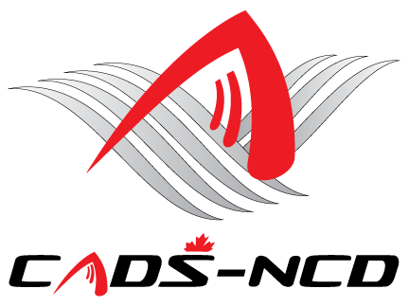
Canadian Adaptive Snowsports - National Capital Division
Virtual Annual General Meeting
Thursday December 3, 2020 – 7:00 PM
Virtual Meeting video and audio conference

(Please see 2nd page to join via video or Audio only call in)

AGENDA

- Call to order and credentials report
- Approval of Minutes from previous AGM (October 16, 2019)
- Business arising from Minutes
- Present and approve 2019-2020 Financial Statements and our
Public Accountant’s Report
- Appointment of Public Accountant for Fiscal Year 2020-2021
- Approval of all 2019-2020 Actions by Board of Directors
- Present and approve 2020-2021 Budget
- President’s Message
- By-Law Amendment – none at the AGM
- Program updates
- Report by Chair of Nominating Committee regarding the
Election of the Board of Directors
- Vote for Board of Directors.
- Introduce/Announce new Board Members / Directors of the
Corporation
- Special Meeting for Board Members to Elect Executive Roles
- Reconvene and Announce Officers
- New Business
- Adjournment

Please see 2nd page to join via video or Audio only call in

You are invited to a scheduled Zoom meeting.

Topic: CADS-NCD Annual General Meeting for fiscal year 2019-20
Time: Dec 3, 2020 07:00 PM Eastern Time (US and Canada)

Join Zoom Meeting
https://us02web.zoom.us/j/88262781046?pwd=eGEzZUs5a3B5UllRSHF5STJUbU1NZz09

Meeting ID: 882 6278 1046
Passcode: 428557

Dial in:
+1 647 374 4685 Canada - Toronto
+1 647 558 0588 Canada - Toronto
+1 438 809 7799 Canada - Montreal

Meeting ID: 882 6278 1046
Passcode: 428557

