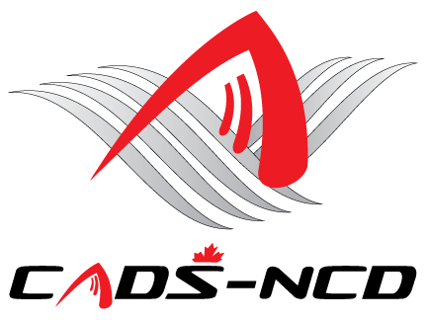

**Canadian Adaptive Snowsports -**

**National Capital Division**

**Annual General Meeting**

**Wednesday October 16, 2019 – 7:00 PM**

**St. Anthony’s Italia Soccer Club**

**523 St. Anthony Street**

**Ottawa, Ontario**

**BOARD OF DIRECTORS APPLICATION**

NAME:

ADDRESS:

PHONE:

FAX:

E-MAIL:

Nomination Support Member #1 Signature: _________________________________

Nomination Support Member #2 Signature: _________________________________

***Note: Nomination Support Members must be CADS/CADS - NCD members in good standing. Nomination applications must be sent and received by the CADS - NCD Nomination Committee Chair Mr. Paul Johannsen at*** [***pkjohannsen@sympatico.ca***](mailto:pkjohannsen@sympatico.ca) ***by no later than October 9, 2019, at least 1 week (7 days) prior to the CADS - NCD AGM, as there will be no nominations from the floor. When sending your application, please cc Nomination Committee member Mr. Bruce Meredith at*** [***brucemeredith@rogers.com***](mailto:brucemeredith@rogers.com)

**CADS EXPERIENCE:**

**WHAT DO YOU HOPE TO ACCOMPLISH AS A MEMBER OF THE BOARD:**

**\*\*PLEASE KEEP YOUR REPLY TO ONE PAGE MAXIMUM LENGTH\*\*\***