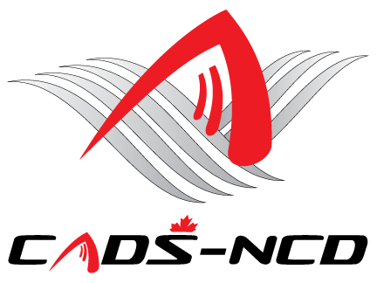

**CANADIAN ADAPTIVE SNOWSPORTS -**

**NATIONAL CAPITAL DIVISION**

**ANNUAL GENERAL MEETING**

**OCTOBER 29, 2018**

Dear Members:

You are cordially invited to attend the CADS - NCD Annual General Meeting.

This AGM will be held Monday October 29, 2018 at St. Anthony’s Italia Soccer Club, 523 St. Anthony Street, (Off Preston Street at the Queensway) Ottawa, Ontario. Phone 613-233-1083.

Light refreshments will be served at 6:15 PM. We anticipate a 7:00 PM start.

The meeting will take place in the upper hall. It is a large wheel chair accessible room. We intend to have signage in place at St Anthony’s directing people to the hall. There is an elevator at the door where a large poster with our CADS-NCD will be placed.

In order to have quorum so the AGM is official, bylaws require that at least 20 **registered** CADS - NCD members 18+ years of age participate. In addition to all Board members attending, we would need 2 or 3 voting adult members in attendance from each program. That may be many members for smaller programs so hopefully larger programs can bring several participants. All programs are strongly encouraged to get their members to attend.

Hope to see you there.

Sincerely yours,

**James Dicks**

**President,**

**CADS - NCD**



**Website:** [**www.cads-ncd.ca**](http://www.cads-ncd.ca)

**A member of Canadian Adaptive Snowsports (CADS)**