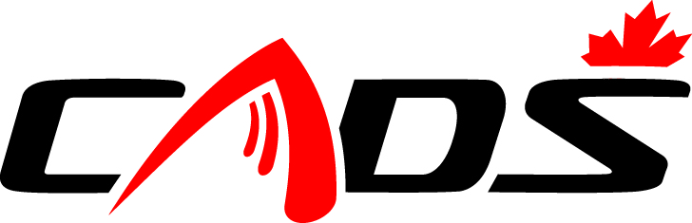
CADS-NCD 2017 AGM NOTICE

CADS-NCD Board of Directors has called an Annual General Meeting (AGM) to be held at 6:00 PM on Wednesday November 1, 2017. The location is St. Anthony’s Italia Soccer Club, 523 St. Anthony Street, (Off Preston at the Queensway) Ottawa, Ontario.

During this AGM an election will be held for two (maybe three) Directors.

All current CADS-NCD members in good standing are eligible to run for these positions. Dedicated members with experience in Administration, Finance, Translation, Information Technology, and or Fundraising are encouraged to apply.

Please fill out the attached Application Form and forward it to our Nominations Committee Chair Mr. David Farough at DFarough@gmail.com and cc Nomination Committee member Mr. Bruce Meredith at brucemeredith@rogers.com no later than October 25, 2017 as there will be no calls for nominations from the floor. Please note that two (2) current CADS-NCD members in good standing are required to support each nomination.

Sincerely yours,
Bernie Simpson
President, CADS-NCD

