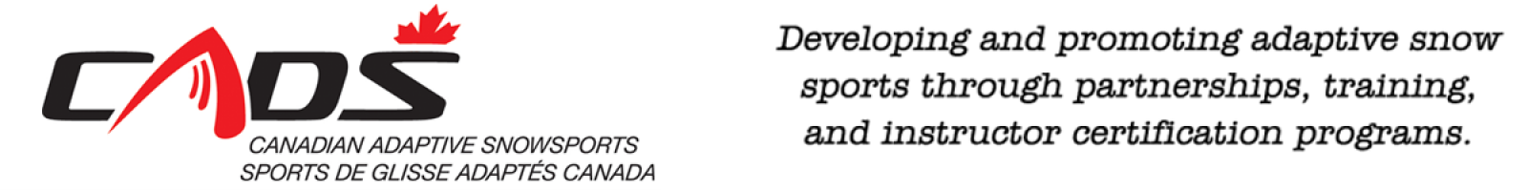

CADS-NCD - Mont CASCADES
Budget 2017/2018

Revenues
Initial carryover $ 958
10 Skiers @ $ 200 registration $ 2,000
Fundraising $ 1,192
Corporate Donation $ 600
Total $ 4,750

Expenses
25 Skiers x 8 weeks x $14 $ 2,800
Plaques / achievement gifts $ 500
Bursary for Festival participation $ 500
Equipment $ 250
Achievement celebration $ 700
Total $ 4,750

Rev. 17Oct ober 2017

