CADS – NCD President’s Report
2016-2017 Ski and Snowboard Season
Presented at CADS – NCD Annual General Meeting
November 1, 2017

Dear Members;

It was my pleasure again to serve as President of CADS – NCD and present my report for the 2016- 2017 ski and snowboard season.

The season got off to an early beginning once the CADS - NCD Annual General Meeting for 2016 finished with the Eastern Pre-Couse being hosted at our Calabogie Peaks Program. Our National Technical Committee continues to promote their New CADS Instructors’ Manual and hammer things home. Our own NCD TC reported that more than ever Level 1 and Level 2 instructors’ pins were awarded this past winter.
Our fleet of sit skis, outriggers and skis at all programs were given quite an overhaul prior to and during the season. Acquisitions of brand new sit skis and replacement parts for old neared $40,000.00. We are in good shape heading out onto the snow this fall and winter.

2016-2017 membership remained consistent with prior year levels at about;
- 494 total registered; including
- 238 instructors/ volunteers, and
- 256 skiers or boarders with various physical and cognitive challenges,
  - 131 students with physical and 125 with cognitive challenges
  - 60 sit skiers and 196 stand up skiers with
- 104 of these skiers or boarders are under the age of 20.
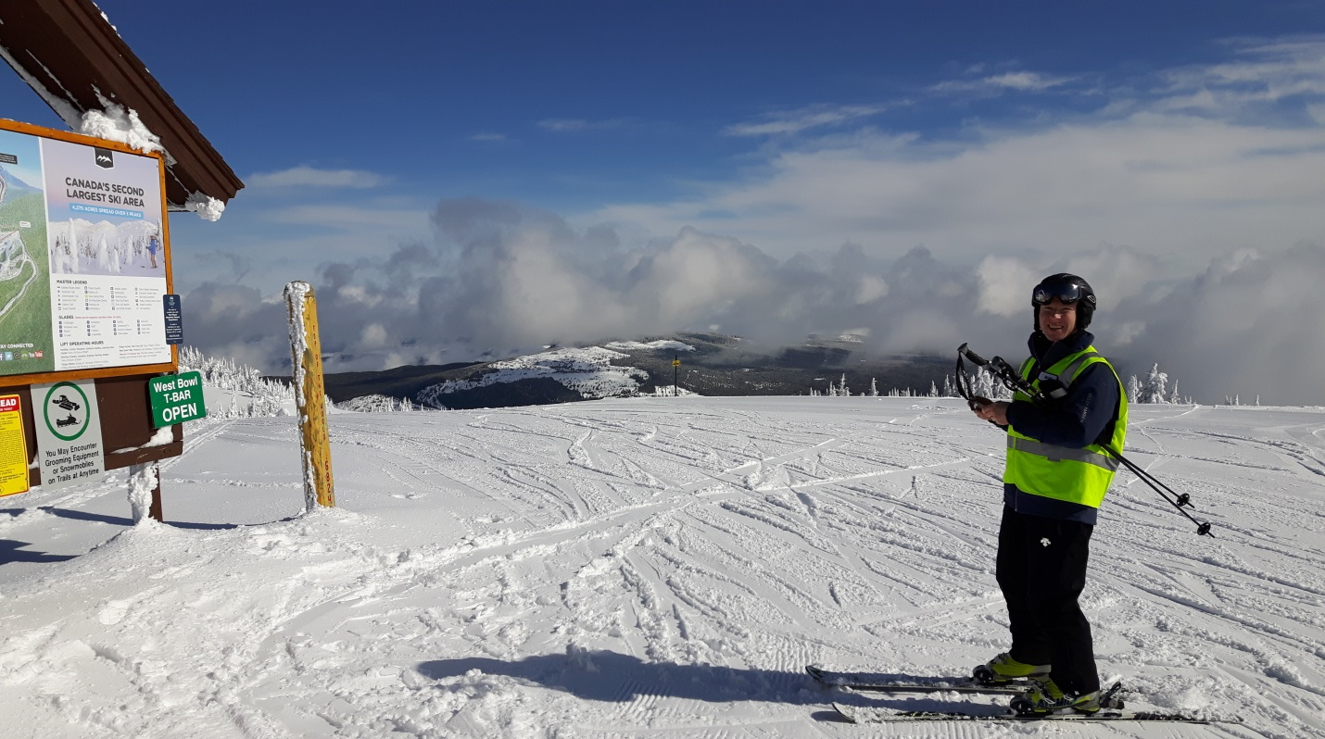

For the first time in seven years I was fortunate enough to participate in our Winter Sports Clinic. Needless to say it was incredible. Not one participant, skier or instructor, left Calabogie without expressing their utmost gratitude for their time spent learning to ski or snowboard. I look forward to going out again this February and if you can spare the time please consider applying to instruct. We anticipate 50 students this winter.

The 2017 CADS Ski and Snowboard Festival at Sun Peaks was well attended by NCD. It is hard to be less than overwhelmed at this resort. Best snow, best sun and the biggest and best of CADS partakers at any of the 41 years of existence. All the meetings, lessons, camaraderie were top notch. It all moves to the East this season as the 2018 CADS Ski and Snowboard Festival will be hosted at Mont Saint Anne Quebec. Do your best to assemble a team of student and instructors to attend this March at Monte Ste. Anne. They say we will have a ton of snow and Ste Anne is as close to a Big Mountain resort in the west as any.

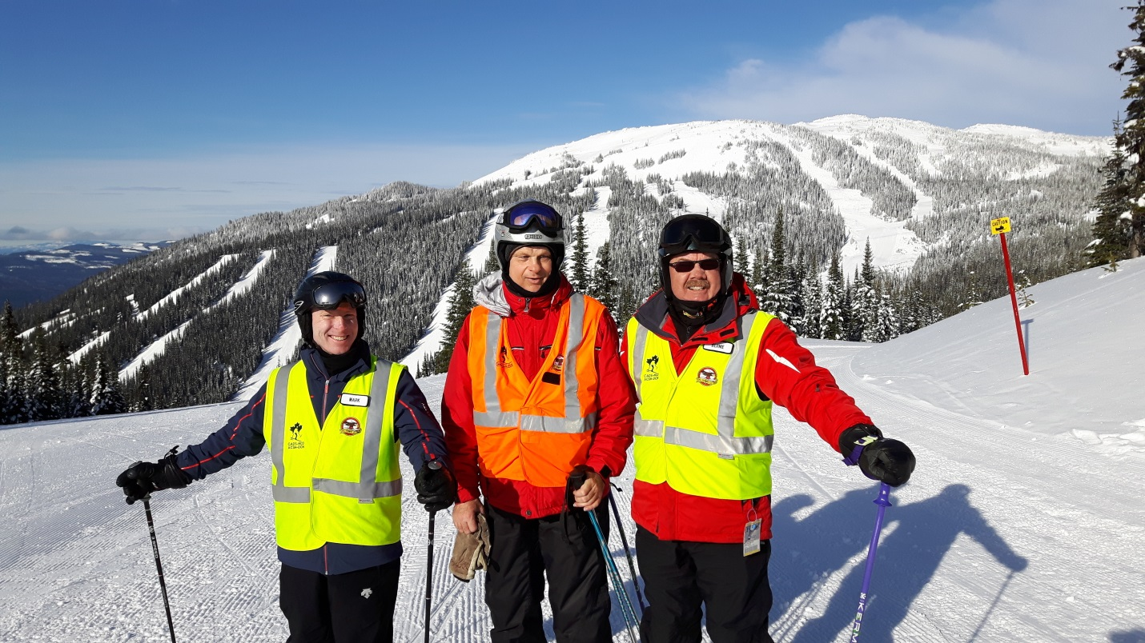

At the Festival Banquet the Annual CADS National Awards were handed out. CADS-NCD picked up a couple of plaques. Congratulation to Mr. Jeff Boucher who won the “Bob Gilmour Inspirational Leader” Award and Mr. Martin Bourgon won the “Instructor of the Year” Award.

CADS – NCD events continue to be well received in the media. Examples include;
- Accessible Media Incorporated produced an excellent video on CADS - NCD Ski Hawks Ottawa Camp Fortune Program.
- Winter Sports Clinic is in a CTV news feature and
- in a True Patriot Love Web site article.

Our condolences go out to family and friends of Pakenham member Rick Ellas, Ski Hawk Alan Trafford and one of the founding members of CADS Nip Bradford of Kimberly B.C.

These were some of the highlights of the past season, I’m sure I left out many and forgot to mention some great people who have been doing exceptional work. My apologies.

Thank you to our Special Event Volunteers and our Board of Directors for holding us all together. All programs had a great year. Their reports are appended below.

Sincerely yours,

Bernie Simpson
President
CADS-NCD

Canadian Association for Disabled Skiing –National Capital Division (CADS–NCD)
Association canadienne pour les skieurs handicapés - Division de la capitale nationale (ACSH-DCN)

1216 Bordeau Grove, Ottawa, Ontario K1C 2M7

Canadian Revenue Agency Charity # 119051514RR0001 visit / vistez le: www.CADS-NCD.ca

Industry Canada Not for Profit Corporation # 005875-1

NCD - 2017 Technical Committee Report
March 20, 2017

Our 2017 season was a big success overall with a few challenges thrown in to keep us on our toes!

This was the first season we offered full Level 1 & 2 certification courses based on the new TC criteria that was introduced back in 2015/2016. The following Level 3 Course Conductors delivered the courses.

Full Level 1 Course:

Al McLarty
Malcolm McKinley
Tim Fitzgerald(VI Module)
Joe Beaudry(VI Module)
Full Level 2 Course:

Tim Fitzgerald
Joe Beaudry
Jeff Boucher

Certification Results:

- 8 New Full Level 1 Instructors
- 15 New Level 1 Module Specialists
- 7 New Full Level 2 Instructors and a few Level 2 Module specialists
- Level 3 course was not held this year.

Level 1 & 2 CSIA Methodology Training:
Special thanks to Al McLarty & Carolyn Mitrow for organizing the CSIA Methodology training this season and the following CSIA Instructors for delivering it: Sarah Lynne Howard, Sean Delaney & Rob Dewar.

Challenges:

- Registration of candidates was complicated by the CADS National website. There were many people who had a lot of trouble or simply could not register on the site. There was also a problem with people simply not bothering to register and would show up anyway. This has been communicated to TC National.
- Training vs Testing during the courses. This has been an issue since the introduction of the new certification criteria and has been communicated to the TC National. Work in progress.
- Scheduling the courses is a challenge given the limited resources and available time during the season. We will continue to manage this to the best of our ability.

Year-End TC meeting is scheduled for Tues April 11 to review results and identify areas of improvement for next year.

Regards,

Malcolm McKinley
CADS-NCD TC Rep.

NCD - Calabogie Adaptive Sports

We had another great year at Calabogie Peaks

The year was action packed with dry land and on hill training, certification and ski improvement opportunities and for the students it meant more time on the hill and trying new techniques. Our training programs is a joint one with Pakenham and we continue to provide excellent sessions and keep developing to fit needs such as advanced tethering technics.

We had a number of fun activities like the 70’s theme day…..I didn’t see a one piece ski suit but the afro hair was present. What about those groovy glasses and peace signs? We had some tied dyed shirts and lots of fun. Another event was our Canada Day in honour of Canada’s 150th birthday. We had red and white and Canadian flags out on the hill. We provided everyone with a CADS/150th t-shirt and they were a big hit.

The weather was excellent this year with no rain and no freezing cold days during our season so we were able to have full capacity with students and instructors coming out for great days. We have had some of our sit-skiers strive to become independent and a number of students making gains in their strength and techniques.

We changed up our fund raising and held the skill-a-thon which raised over $9,000 for us and will afford us to purchase two sit-skis, a snow wing and some outriggers. We hope to make a determination on jackets or vests with the new logo and greater visibility in the upcoming months. We were also very fortunate to have a number of independent donations that have been huge in assisting us this year. We held our annual Patron Appreciation Day and moved it from the top of the hill to at the base and found that people made contributions to us that day as well. This was very nice indeed.

We had a new young skier join us this year, Brian Rowland, who came to festival and was invited to join the para-Olympic team next year so we are so very excited for him and his success. In his thank you note to NCD he mentioned that he now knows the meaning of the CADS family and is so excited to have had the year and opportunity at Festival and at the Rising Stars Program.

Next year we will see some change in instructors as we will have some heading off to university and we will continue to develop those instructors who come out to make them stronger and give them more confidence on the hill.

Calabogie ran the Eastern Pre-course in 2016-2017 and have been successful again for 2017-2018 Pre-course so are happy to be able to support the development of those in attendance.

This summer we are going to be working on adapting the Silver Star registration program for our use. It includes student profiles, scheduling, medical alerts, and emergency contact, training and certification records. It is a wonderful program and will dovetail nicely into the new CADS registration program. It will be a better system as once we load it with the content it will be easy to renew individuals each year.

So the year ahead will be planned and developed and we will hit the ground running next fall.

Until then – it’s time to enjoy the non-snow days and make the best of summer.

Deb Blimkie
Program Director – NCD Calabogie Program

NCD – Winter Sports Clinic 2017 for Injured
Soldiers and Veterans Year-End Report

Planning

The first monthly meeting for the Winter Sports Clinic (WSC) 2017 planning committee was held on June 15, 2016. Both the target level of participation (30 injured soldiers and veterans) and budget ($85K) were established for the clinic. This commitment required significant risk management on behalf of the committee as clinic planning was initiated with only a $3K reserve and a $4K of credit with Trico Evolution Printing and Accent Logos. By the mid-August meeting, the following planning committee was proposed:

- Chair Alex MacPherson
- Co-Chair / VIP coord Jonathan Inman
- Treasurer Phil Cassidy
- Support / Coordination Trish and Dale Cross
- Communications Michelle Bavington
- Fundraising Dan Fleming, Michael Stagg

- Past Chairs Clay Dawdy, Neil George

Schedule

After deconfliction with Calabogie Peaks, the dates for WSC 2017 were set to February 5-10, 2017. However, this timeframe overlapped with the planned date for Community Living Day at Calabogie Peaks of February 6, 2017. The event coordinator, Clay Dawdy, kindly moved their date forward to January 30, 2017 to accommodate the WSC.

The application window for WSC 2017 was set between September 19 and December 13, 2016. Selection of participants and instructors was done on December 14, 2016 with all acceptance letters for the clinic sent out as of December 18, 2016.

Fund Raising and Partnerships

True Patriot Love (TPL) doubled their funding contribution to $50K for this year. An MOU was signed by the WSC Chair that detailed the responsibilities and the expectations of the agreement. A TPL representative with two of their key sponsors visited during the WSC and verbally committed to the clinic going forward.

Regional branches of the Royal Canadian Legion significantly increased their support to the WSC this year. With the precedence set by their support to the Invictus Games, donations raised by their Poppy Fund could now be directed towards veterans’ sports. A total of $20K was received by the WSC, primarily as donations given in person by Legion representatives during the week of the clinic.

Lépine Group again contributed $10K this year. Francis Lépine was the guest of honour during the banquet on February 8, 2016 to recognize his ongoing support not only to the WSC, but also to the Calabogie Program.

Calabogie Peaks Resort continues to be a primary partner for the WSC. They provide a significant reduction in accommodations costs to the clinic as well as deliver outstanding support throughout the week. Without their backing, the continuity of the WSC at its current level would be difficult.

Both Community Living Renfrew and Sledge Hockey Eastern Ontario (SHEO) were instrumental in supporting the Tuesday evening sledge hockey event. Despite the adverse weather conditions, this alternate activity was a participant favourite.

Outreach

Additional efforts were made this past year to increase awareness of the WSC. Several kiosk-based engagements were coordinated including the Calabogie Military Appreciation Day (February 28, 2016), CSE’s Charitable Campaign day (September 8, 2016), the Army Run (September 16-17, 2016), and the Northern Micro Showcase (November 17, 2016). An additional effort was made to further ties with Veterans’ Affairs Canada (VAC), with Dan Fleming and Phil Cassidy presenting to over 30 case workers on December 14, 2016.

On social media, both a Facebook Group (CADS-NCD Winter Sports Clinic - Calabogie, On) and Twitter account (@CalabogieWsc) were established to promote the clinic.

WSC 2017 was featured prominently on two CTV news events.

http://ottawa.ctvnews.ca/video?clipId=1062443

http://www.ctvnews.ca/video?clipId=1053407

Two additional efforts are still ongoing as of writing this report: the final editing of a WSC 2017 specific video; and a documentary-style production to cover the background history of the WSC.

Attendance

For WSC 2017, there were a total of 28 participants, 9 spouses, 29 instructors and 12 volunteers. Within the volunteers, those that were current CADS members but not yet and instructor were given the option to be employed as Teaching Assistants (TAs). Given the last minute push with VAC, we received several applications after the set window and had a ‘wait list’ of 8 people of which one was accepted after a participant withdrew the week before the clinic.

For the first time, on the application we asked the participants what language of instruction they would prefer. A total of 8 participants had indicated they would prefer instruction in French and were so accommodated.

WSC 2017 Closure and 2018 Initiation

The final meeting of the WSC 2017 planning committee is set for March 22, 2017 where the collected participant feedback and ‘lessons learned’ from the clinic will be discussed.

The first meeting for the WSC 2018 planning committee will be mid-June, 2017. The dates for WSC 2018 have been set for February 4-9, 2018 at Calabogie Peaks Resort.

Alex MacPherson
Committee Chair / Program Director
Winter Sports Clinic 2017

March 19, 2017

NCD – Mount Pakenham Adaptive Ski Program
2017 Year-End Report

At the beginning of this ski season we had a change in the Management Team. Allan Braun resigned as the Program Coordinator for health reasons, but Dave Hoffman, who was already very busy as registrar offered to be Interim Program Coordinator. Allan stayed on as a Director on the Board for this season.

Before the season began, the CADS family at Mount Pakenham was hit with very tragic news. Rick Ellas, a dedicated, long-time volunteer with our program was killed in a tragic motor cycle accident. Rick’s family recognized his dedication to CADS and asked mourners to donate to CADS-Mount Pakenham in Rick’s honour. It was a sign of the respect that Rick has in the community that our program received a considerable donation in Rick’s name. (We would have preferred to have Rick on the slopes, however.) During our year end celebration, we presented the first RICK ELLAS MOST IMPROVED SKIER AWARD to Janice Boeyen. This award will be awarded annually. The recipient receives a small plague to keep and there is a larger award plaque for the CADS room.

Skiing takes place on Thursday afternoon and evenings, Friday afternoon and evening, Saturday morning and afternoon and Sunday morning and afternoon. We will be looking at whether or not we can expand our program to other days.

We were able to place 57 participants out of 65 applicants. We introduced our first snowboard lesson this year. We had one broken leg during a lesson and we had one withdrawal due to a lack of desire to continue. We filled one lesson time with a skier off the waiting list.

There seems to be a continuous attrition and recruitment of volunteers. It is more challenging to bring in younger volunteers that might develop a long term relationship with the program. We had three volunteers withdraw mid-season due to various reasons but were able to compensate by adjusting the schedule.

Registration

We completed our second year with online registration. There is one participant that requires paper forms due to no computer access. This has proven to be quite successful and eliminates a great deal of data entry by the registrar. Scheduling is also done online which enables participants to see their schedule anytime and provides easy access by all volunteers to the schedule and contact info for participants and volunteers.

We would like to be able to move to electronic payment if possible.

CADS National Membership continues to be problematic for some of our families where there are two or more participants and / or volunteers. The Avectra system allows one person per email address which forces families to acquire and manage extra email addresses. This has caused problems and delays in completing the registration process. Christian indicated to one family that this would be changing next year.

Skiing Management

Due to the success of the online registration application we intend to add new functionality to enhance the actual ski program. Specific areas to be addressed include finding substitute instructors, skier progress reports including history, and disseminating cancellation information. There is also some talk about tracking course training registration.

Ski In School Program

This year, the Ski In School Program was coordinated again by Bob Robertson. The program runs from early January to March break. This year there was an increase in the total number of lessons. In total we had 32 this year ( compared to 25 last year). We had one school with 4 students who cancelled due to weather conditions. Potentially then, we could have had 36 lessons this year, representing nearly a 50% increase over last year.

While last year we supported 1 sit ski lesson (1 other cancelled), we had 6 this year, with one other parent enquiring about sit skiing for their son for next year. We also had one snow slider compared to none last year. Therefore, instructor support needed overall increased, including more demand for sit skiing instructors.

Several schools and students were repeats from last year, and predominately from Arnprior, Barrhaven/Kanata and Lanark County.

Fundraising.

Our annual Ski A Thon held on March 5 this year was successful – though not as successful as the year before. However, 2016 was an exceptional year so we could not expect to duplicate that success every year. Still, we received about $5,000.00 in donations. (Some money is still coming in.) We also received over $2,000.00 in donations in honour of Rick Ellas.

Our Year-End celebration, organized by Amy Booth and her team, was also another success. In fact, the success of all our events is due primarily because we have so many dedicated volunteers who step up to the plate when help is requested.

Overall, we have had a very successful season at Mount Pakenham – CADS-NCD.

Submitted by Allan Braun, Mount Pakenham Program
NCD – Mont Cascades Summary 2017 Season

Another stellar season on the books.

The addition of new volunteers allowed us to accept a number of new students this year.

The actual numbers remained steady at 10 skiers with some not returning from last season.

We had much certification going on. 2 people got Level II CADS, 2 people CSIA 1, 1 person has started CSIA II and 1 received Coach certification.
As usual, Vicki provided ski improvement sessions each Saturday morning with attendance at 99%.

I had admin help this year with my Mom joining the team in the morning to take care of all the paperwork, monies collected and distribution of the lift tickets.

Our fundraising was unparrallel with a Corporate donation of $5,000 from the Meirins Family and Lisa Mierin’s & her husband’s foundation. My company has also donated $500 (so far) – Brokerlink – and am expecting another $500 within the next couple of months on top of our normal fundraising efforts. This will go a long way toward the purchase of a 2nd junior sit ski.

Speaking of Sit Ski .. we now have 3 sit skiers! With this exposure out on the hill there has been lots of interest in what we do and we all have had multiple opportunities to answer questions from the general public.

Our “Hockey Day In Canada” was, as always, a hit and we also had “wear your crazy shirt or favorite superhero sweater day”. Makes for interesting uniforms out on the ski hill.

Mont Cascades, ever supportive, stayed open for our final day – we were the only group there as we had our Achievement Celebration that day. We were able to get our “race” in. This year was a different format .. starting and finishing gate only, guess how many turns and better your time the 2nd run. Everyone loved it as it’s truly “at your own pace” and not as intimidating as gates can be for our brand new nervous skiers.

Incredible progression on all fronts this year .. it was a very challenging task to hand out the awards.

Our banquet was incredible well attended with 50 people coming, skiers, volunteers, friends & family. We took over the whole bar and it was so much FUN!

We are all looking forward to next season .. again!

Theresa Arsenault
Program Coordinator

NCD – Sommet Edelweiss Final Report

Membership

We are just slightly larger than last season with 57 participants and 86 volunteers and we are on the verge of not having enough volunteers each week but somehow things work out OK. We managed to recruit 6 new excellent volunteers during the ski season which relieved a lot of the shortage that we experienced at the start of the season. We had 11 volunteers step away from the program between 18 Dec and 8 Jan with a variety of reasons, pregnant, time constraints and injuries being the biggest contributors.

Budget

Our only major purchase for the season was a Dynamique Sit Ski for approx. $5800.00 delivered to Ottawa. We will remain within our budget and will have reduced our reserve by the end of the season. At the end of the season we ordered two sets of stand-up outriggers, two sets of bi-ski banana skis and a lot of spare parts for our outriggers. We will be ordering 13 handles for the back of all of our Mountain Man fleet from Mountain Man. When we bought the older Mountain Man sit skis the handles were not available but they make maneuvering the sit skis much easier and increase the safety when getting off of the lift. I do not have a final balance but we will be in the black for the season even with the end of season purchases.

Long Serving Members Pins

We presented our 5 year pins on the weekend of 11 and 12 Feb in conjunction with our group photo on each day. We handed out 46 pins ranging from 5 to 35 years of service. We have a huge number of 3 and four year veterans that will be recognized in the next couple of years. The pins were greatly appreciated both for the design of the pin and the card but more importantly for their recognition. Most pins went directly onto the volunteers coats.

Schedule

Our schedule is posted on our website and went according to plan with only one day cancelled for weather, Sat 25 Feb. Although the hill was open that day it was raining heavily and eventually the hill closed at 1:15. One Tuesday trainings session was cancelled as well for weather.

OCTC Day Monday 20 Feb Ontario Family Day

The Ottawa Childern’s Treatment Centre was completed on ON Family Day 20 Feb. It was deemed to be a huge success with the largest turn out of nine kids coming out to experience downhill skiing with the majority being first time skiers. The weather was perfect and the feedback from the parents, participants and OCTC staff was very positive. I believe the event was conducted well within the budget. Special thanks to all of the NCD programs for providing volunteers for the OCTC event it couldn’t have been done without the full support of all of the hills.

Spinal Cord Injury Ontario “Give ‘er a Go” day Tuesday 28 February

This is a new undertaking for CADS Edelweiss and we are working with Spinal Cord Injury Ontario to round up some people for a dedicated “Give ‘er a Go” day. All of the participants were in sit skis and we had the cream of the crop/high level tetherers that easily managed the new skiers in any configuration of sit ski. Even though it was a number of first time sit skiers I had 100% confidence that the volunteer tetherers were able to assess the participants, choose the correct sit skis, adjust the sit skis, and maximize the new athletes fun and learning on the hill. It was proof of the culmination of a good training program. Most of the tetherers were pretty new to the program but excellent tetherers. It was really a stress free day for me as Edelweiss Coordinator and proof that we are putting the necessary rigor into training our people.

CADS Level II Training 28 Feb, 4 & 5 March 2017

We ran a CADS Level II course at Edelweiss with Tim Fitzgerald and Jeff Boucher as course conductors. We graduated 7 new CADS Level II instructors and 4 module passes and two needs improvement candidates. It was run as a testing course versus a teaching course and all candidates were made aware of that prior to commencement of the course. Of note was the amount of reading and studying that the candidates had done prior to arriving. It was fantastic to see so many folks take an interest in not only getting the qualification but really wanted to become great at their craft. This was the first Level II course given under the new scheme of courses and it was a bit of a learning experience for both the students and instructors.

CADS Edelweiss Webpage

We continue to improve our webpage and will sit down in the next couple of months with Colin Moden to give it the end of year cleanup and improve the content for the coming season. It is a huge improvement over past years and is getting much closer to what we need. Colin has been fantastic.

CADS – NCD Edelweiss Steering Committee

Jeff Boucher
Julie Stewart
Joe Beaudry
Tim Fitzgerald
Pierre Goulet
Amy Johnston
Louis Poirier
Luc Legault
Cathy Presseau

We will be trying to get a couple of parents or participants onto the steering committee because we are all volunteers right now and that needs to change.

Respectfully submitted;

Jeff Boucher
Program Coordinator

NCD – Ski Hawks Ottawa 2017 Year End Report

Membership

Ski Hawks had a strong contingency of guides this year which we find is necessary as very frequently we get up to 5 cancellations on the day of the program from guides who are sick or can’t leave work. Our skier membership was down slightly but we averaged 18-19 skiers per week. We will be doing a review of the current skiers before the summer to gage what the attendance might be like next year and look at recruitment if needed.

Certification

It’s been a very busy year for our Ski Hawks volunteers. Five members achieved their CSIA Level 1 and two others completed their CSIA Level 2, with one other just a few points off of receiving his. The number of certifications this year was unexpected and in order to manage our budget in subsequent years, we will be reviewing our policies and those of CADS-NCD so that SHO is consistent with CADS-NCD policy.

Several of our members worked towards upgrading their CADS Levels and one of our members became one of the first course conductors for snowboards and has already given two of our members their Level 1 CADS snowboard.

Overall, the program has been strengthened by the hard work of our members who have dedicated their time to improve their skills, and it is greatly appreciated.

Volunteer CADS Appeciation Pins

This year we will be awarding three 5 year pins, three 10 year pins, one 25 year pin and one 30 year pin. It is important to note that the 25 year pin is being awarded to skier Murielle Arseneau who has been organizing rides and social events for the Club since 1990!

Programs

There were 9 weeks of Wednesday night skiing and one weekend day which was the best ever attended. SHO representation at the Mont Avila CADS-NCD trip was also well attended and had our biggest numbers ever.

Safety and Training

Training occurred in December was a full day for the first time. The day was divided up between guiding training for new guides and situational training for the more experienced guides who were match up with the new volunteers in the afternoon to come up with solutions to assigned tasks. The program has continued to strengthen each year as guides are more thoroughly trained and personal ski training options are continued to be offered. The safety questionnaire is also mandatory and there are plans to change it up for next year.

Program Awareness

The Ski Hawks program was televised on Accessible Media Inc. in February. Skiers and volunteers were interviewed by Dave Brown, formally of CBC radio and also visually impaired. Dave and his cameraman Darcy, did an amazing job of showcasing the program and the spirit of those who volunteer and ski with us.

Annual General Meeting

The annual general meeting will be held at the Fox and Feather restaurant on Wednesday, June 14. There are no positions on the Board of Director being voted on this year however, we are continuing to encourage SHO members to think about succeeding current board members. One of our returning members who has been away from the program for 3 years has demonstrated an interest in working with the technical director and we are hoping that others will step forward. The club president is also in her last term and will be looking for someone to follow in her footsteps.

Submitted by

David Farough
Ski Hawks Ottawa Rep on CADS – NCD Board

and

Carolyn Mitrow
President,
Ski Hawks Ottawa

